MT3608 2A Max DC-DC Step Up Power Module Booster Power Module
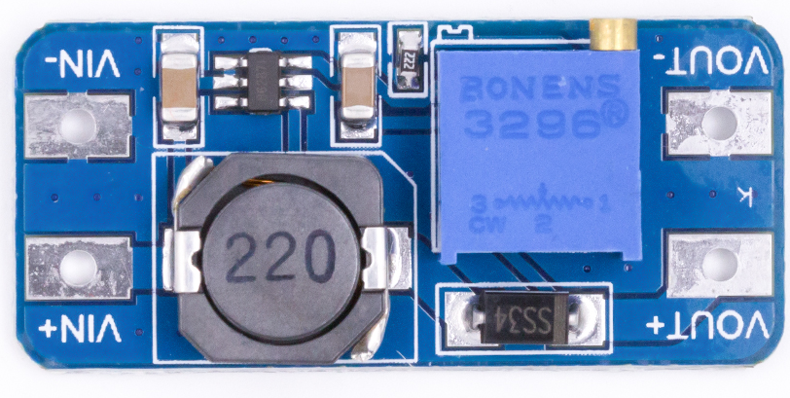
Specification
1. Input voltage:DC 2V-24V
2. Output voltage: DC 2.9-28V adjustable
3.Conversion efficiency: Maximum 93%
4. Output current: maximum output current 2A, long run 1.2A or less, 1A or more to strengthen the heat dissipation
5. Output power: maximum 10W

Special Tips
1. The positive and negative poles of input and output can not be reversed, otherwise the module will be burned directly;
2. Maximum input voltage and maximum output current can not be satisfied at the same time, long time use can not be high voltage, high current, hot swap, pay attention to strengthen heat dissipation;
3. The maximum output power is 10W, this is the limitation, please leave a margin for use;
4. Do not carry a load regulator.
5. This is a boost module, use the input voltage is less than the output voltage;
6. For the first time use, first adjust the potentiometer counterclockwise 20 turns to raise the output voltage, and then power on the operation.

Functional Diagram
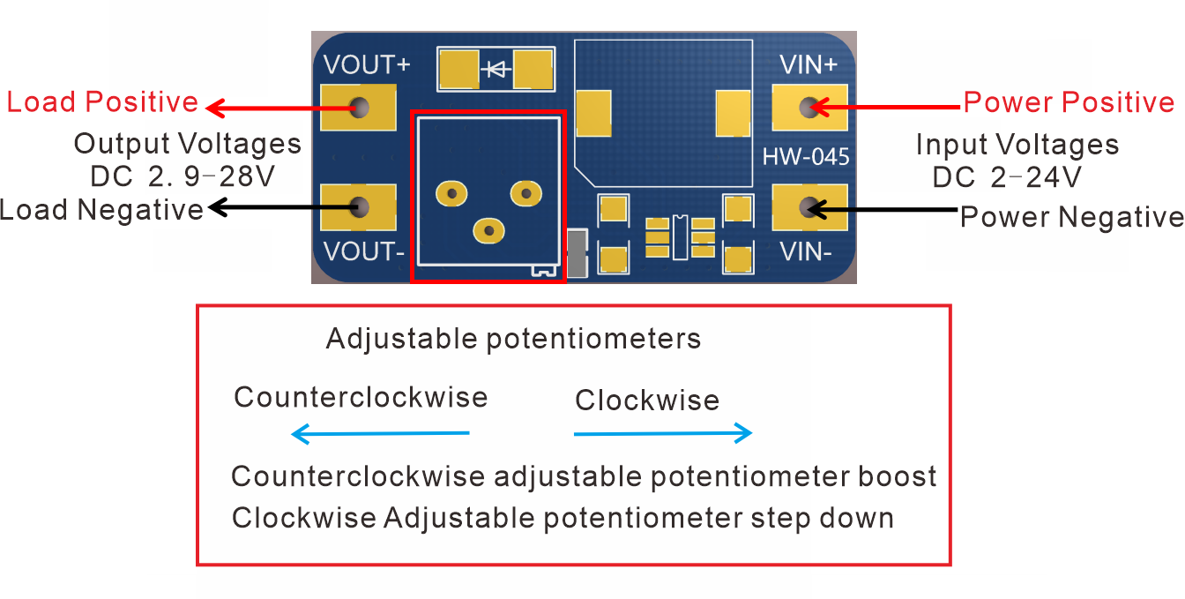

Dimensional drawings

