# **Waveshare BME280 Environmental Sensor, Temperature, Humidity, Barometric Pressure**

**SKU: 1219057**

## **Pinouts:**

|  |  |  |
| --- | --- | --- |
| **PIN** | **I2C** | **SPI** |
| VCC | 3.3V/5V power supply | |
| GND | Ground | |
| SDA/MOSI | I2C data | SPI data master output/slave input |
| SCL/SCK | I2C clock | SPI clock input |
| ADDR/MISO | I2C address chip selection, high level (default) address: 0x77; low level address: 0x76 | SPI data master input/slave output |
| CS | NC | SPI chip selection, low active |

## **Dimensions**

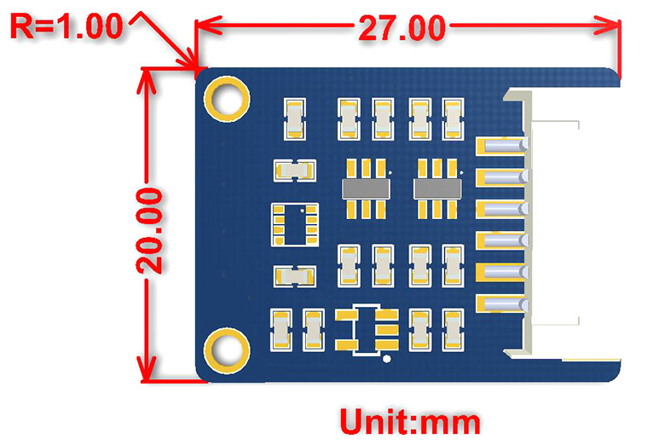

## **Sensor Parameters Comparison:**

|  |  |  |  |  |
| --- | --- | --- | --- | --- |
| **MODEL** | | [BME280](https://www.waveshare.com/bme280-environmental-sensor.htm) | [BME680](https://www.waveshare.com/bme68x-environmental-sensor.htm?sku=24245) | [BME688](https://www.waveshare.com/bme68x-environmental-sensor.htm?sku=24244) |
| **DETECTION SUPPORT** | | Barometric pressure, Environmental temperature, Relative humidity | Barometric pressure, Environmental temperature, Relative humidity, VOC gas change detection (supports IAQ calculation in combination with the software package) | Barometric pressure, Environmental temperature, Relative humidity, VOC and VSC gas change detection (supports IAQ calculation in combination with the software package, and integrated AI function) |
| **COMMUNICATION INTERFACES** | | I2C and SPI | | |
| **TEMPERATURE SENSING** | **RANGE** | -40~85°C | | |
| **ACCURACY** | ±1.0℃ (0~65℃) | | ±0.5℃ (0~65℃) |
| **HUMIDITY SENSING** | **RANGE** | 0~100%RH | | |
| **ACCURACY** | ±3%RH | | |
| **BAROMETRIC PRESSURE SENSING** | **RANGE** | 300~1100 hPa | | |
| **ACCURACY** | ±1.0hPa (0~65℃) | ±0.6hPa (0~65℃) | |
| **GAS SENSING** | | - | supports VOC gas change detection | supports VOC and VSC gas change detection |
| **DIMENSIONS** | | 27 × 20mm | | |