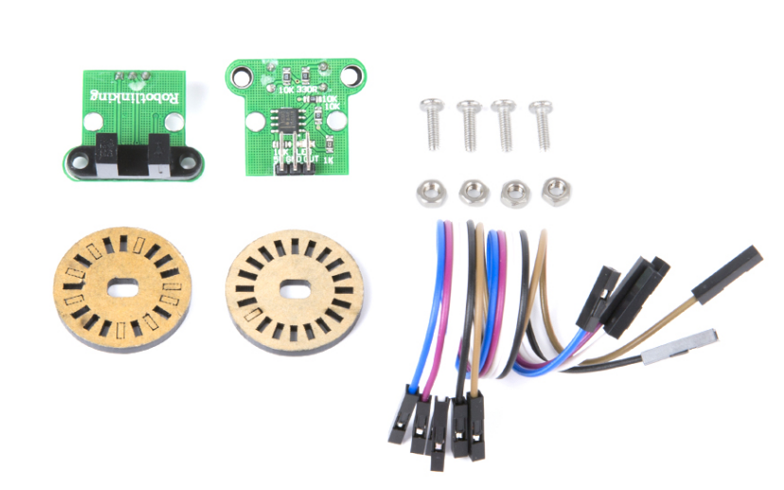
Product Description
This is a kit for testing motors, including 2 HC-020K speed sensors and 2 20-grid code disks and other accessories.HC-020K speed sensor is a counter-radial sensor, with high resolution, output waveform regularity and many other advantages. The sensor is a wide-voltage, high-resolution, short response speed, switching output speed measurement module, with the black code disk can measure the motor speed (the specifications of the motor measured, and the code disk related).
The code disk is now provided with a D-hole ID of 4mm, which can be used for motors with an output shaft of 4mm diameter. On the trolley, there are two-way wheels are not retrofitted with gears, through the use of D-hole code disk, we can easily install the code disk to the rotation axis of the tank wheels, due to the use of 20 grids of the code disk, the diameter of the tank wheels is 4.7cm, we can calculate the minimum precision that the code disk can be detected as:3.14*4.7cm/20=0.74cm=7.4mm, which can satisfy the common precision control of tank car movement.

Product List
HC-020K speed sensor | 2
20 Grid Black Code Plate | 2
20cm Female to Female Dupont Cable | 6
M3*10 round head screws | 4
M3 Nut | 4

Specification
Module operating voltage: DC 4.5-5.5V
Transmitter voltage drop: Vf=1.6V
Transmitter current: If<20mA
Signal output: A, B two-way; TTL level
Resolution accuracy: 0.01mm
Measuring frequency: 100KHz
Code disk diameter: 24mm
Code disk D-hole inner diameter: 4mm
Code disk resolution: 20 lines
Speed sensor configuration: the configuration can be measured 1-way motor speed
Principle of Velocimetry
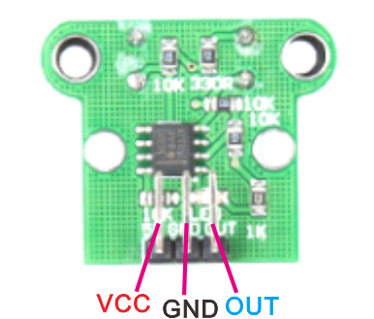
OUT is the frequency output. A microcontroller timer/counter can be used for pulse capture, assuming that the code disk is a 20-grid, generating 20 pulses per revolution.
Calculate the speed method:
If we get 40 pulses in 1 second, then the speed is
40/20=2 rpm, according to the tire diameter D, the actual speed can be calculated as πD*2/sec.
Calculate the mileage method: the number of pulses of the counter/20*πD

We can use the following formula to calculate the speed of the motor (in revolutions per minute RPM):
RPM = 60 / (time interval * number of scales)
where the time interval is the code disk rotation time in minutes and the number of scales is the number of scales on the code disk.
The measurement frequency of the HC-020K is 100 kHz and the number of scales on the coding disk is 20. We can calculate the speed of the motor by substituting these parameters into the RPM formula.
RPM = 60 / (Time interval * Number of scales)
Since the measurement frequency is 100 kHz, i.e. 100,000 samples per second, we can set the time interval to the time of each sample.
Time interval = 1 / Measurement frequency = 1 / 100,000 = 0.00001 seconds = 10 microseconds
Substitute these values into the formula to calculate the speed of the motor:
RPM = 60 / (10 microseconds * 20) = 300,000 RPM
Therefore, with the given parameters, the HC-020K can measure a motor speed of 300,000 RPM.
Note: This is a theoretical value and actual measurements may be affected by the performance limitations of the sensor and encoder disk as well as measurement errors.

