AC/DC powered ESP8266 WIFI single-channel relay module ESP-12F development board secondary development

I. Overview
ESP8266 single relay development board equipped with ESP-12F WiFi module, I / O port full pinout, support AC90-250V/DC7-12V/USB 5V and other power supply. Provide Arduino development environment reference code, suitable for ESP8266 secondary development learning, smart home wireless control and other occasions.

II. Functional Features
1. Onboard mature and stable ESP-12F WiFi module, large capacity 4M Byte Flash;
2. The I/O port of WiFi module and UART program download port are all exported to facilitate secondary development;
3. on-board AC-DC switching power module, power supply mode support AC90-250V/DC7-12V/USB5V;
4. RST reset button of onboard WiFi module;
5. ESP-12F supports the use of Eclipse/Arduino IDE and other development tools to provide reference programs in the Arduino development environment;
6. on-board 1 5V relay, output switching signal, suitable for controlling the load within the operating voltage of AC 250V/DC30V;
7. on-board power indicator, 1 programmable LED and relay indicator.

III. Hardware introduction and description
1, board size: 80 * 50mm
Weight: 34g
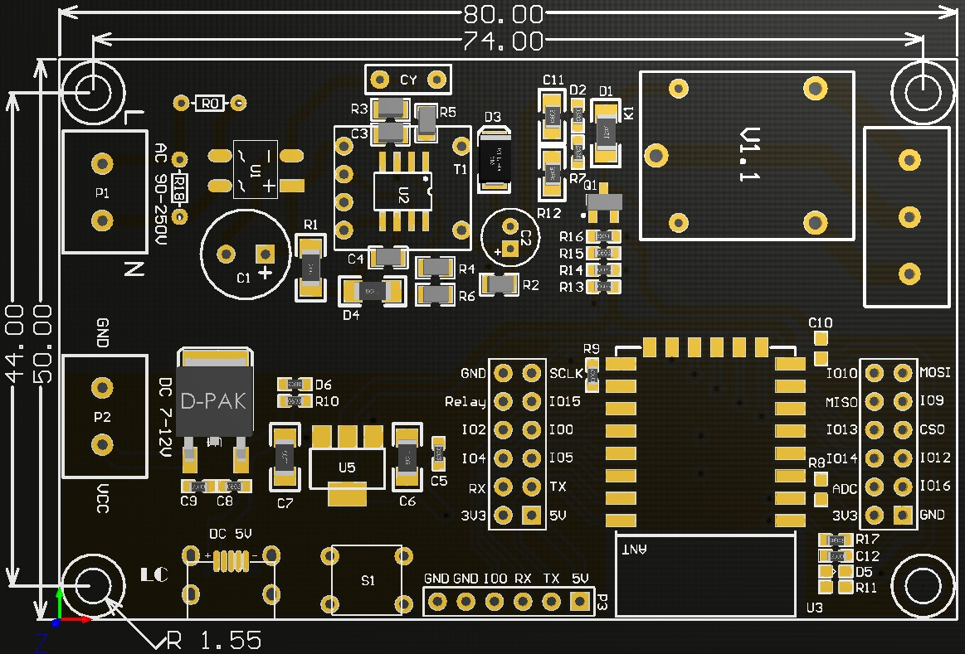
2, Interface Introduction
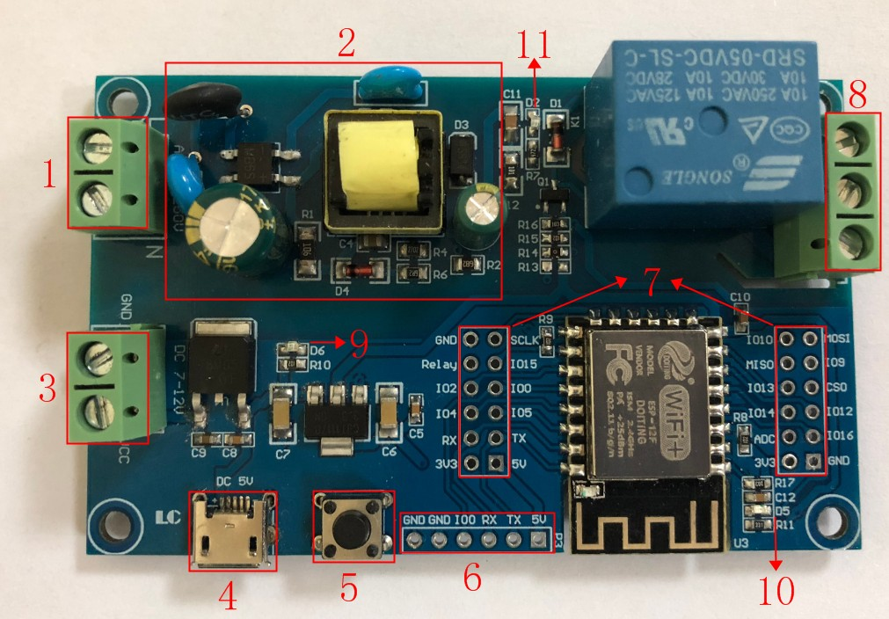

1, L, N: AC90-250V power supply;
2, AC90-250V to DC5V switching power supply (please do not touch here directly with your hand when using AC power supply!!!) ;
3, VCC, GND: DC7-12V power supply;
4, Micro USB: DC5V USB power supply;
Note: AC90-250V, DC7-12V, DC5V USB three kinds of power supply can choose one.
5, 6X6mm key: ESP8266 reset key;
6, UART program download port: ESP8266 GND, RX, TX, 5V are connected to the external TTL serial module GND, TX, RX, 5V, IO0 and GND need to be connected to the download, the download is complete, and then disconnect the connection between IO0 and GND;
7, GPIO pin-out port;
8, relay output:
NC: Normally closed terminal, shorted to COM before the relay is activated, and suspended after activation;
COM: common terminal;
NO: normally open terminal, before the relay is absorbed, shorted to COM after the relay is absorbed.
9, power indication LED;
10, programmable LED;
11, Relay indication LED: lit when suction closed.

3，GPIO Pinout Port Introduction
Serial number | Name | Functional description | Serial number | Name | Functional description
1 | GND | Power ground | 13 | IO10 | GPIO10
2 | Relay | Relay drive port, use IO5 to drive by default, if you want to use other I/O to drive the relay, you can remove R14 and then connect the I/O to drive the relay to this Relay pin | 14 | MISO | Slave Output Host Input
3 | IO2 | GPIO2; UART1_TXD | 15 | IO13 | GPIO13; HSPI_MOSI; UART0_CTS
4 | IO4 | GPIO4 | 16 | IO14 | GPIO14; HSPI_CLK
5 | RX | UART0_RXD; GPIO3 | 17 | ADC | A/D conversion result. Input voltage range 0 to 1V, value range: 0 to 1024
6 | 3V3 | 3.3V power supply | 18 | 3V3 | 3.3V power supply
7 | SCLK | Clock | 19 | MOSI | Host Output Slave Input
8 | IO15 | GPIO15; MTDO; HSPICS; UART0_RTS | 20 | IO9 | GPIO9
9 | IO0 | GPIO0 | 21 | CS0 | Chip Selection
10 | IO5 | GPIO5 | 22 | IO12 | GPIO12; HSPI_MISO
11 | TX | UART0_TXD; GPIO1 | 23 | IO16 | GPIO16
12 | 5V | 5V Power Supply | 24 | GND | Power Ground
4，Arduino Development Environment Setup
ESP8266 supports Eclipse/Arduino IDE and other development tools, the use of Arduino to be relatively simple, the following is the Arduino development environment to build methods：
1, install Arduino IDE 1.8.9 or the latest version;
2, open Arduino IDE, click File - Preferences in the menu bar, enter Preferences and click Add URL in "Attach Board Manager URL":
http://arduino.esp8266.com/stable/package_esp8266com_index.json,
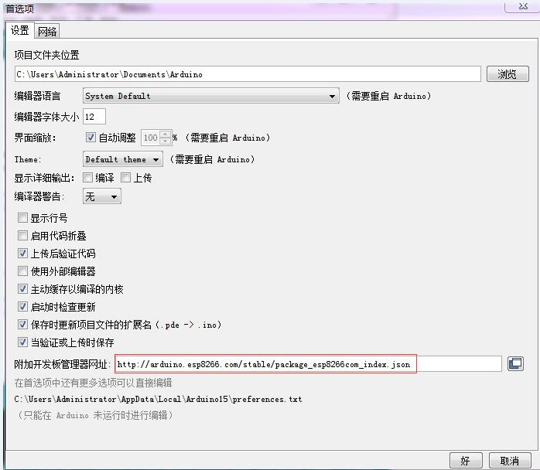

3, click the menu bar of the Tools - Development Board - Development Board Manager, and then search for "ESP8266" to install the Arduino support package for ESP8266 2.5.2 or the latest version!
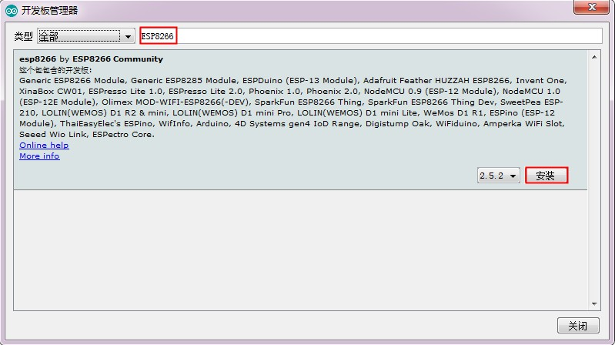
5, program download
1, use jumper caps to connect IO0 and GND pins, prepare a TTL serial module (e.g., FT232) plugged into the computer USB, serial module and development board connection method is as follows:
TTL serial port module | ESP8266 development board
GND | GND
TX | RX
RX | TX
5V | 5V
2, click the menu bar Tools - Development Board, select the development board for ESPino (ESP-12 module)
3, open the program you want to download, click Tools - Port in the menu bar, select the correct port number.
4, click "Upload" and the program will be automatically compiled and downloaded to the development board, as follows:
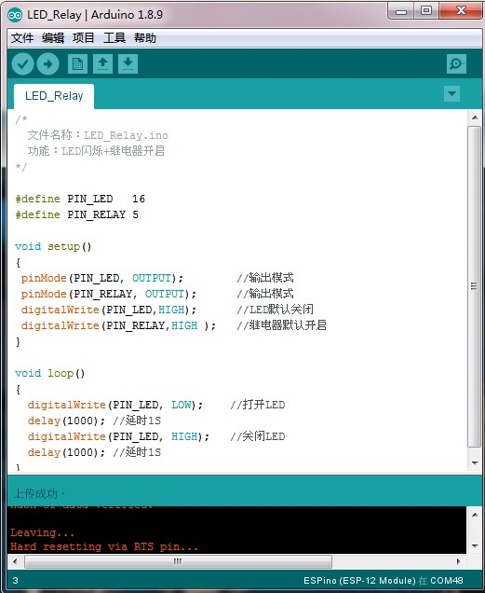
5, and finally disconnect IO0 and GND, the development board re-power or press the reset button program can run.

