Water Pressure Sensor G1/4 1.2Mpa

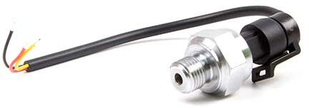

**Description**

This is a pressure measuring sensor. You can use it in clean, non-corrosive gas and liquid.

# Features

Compact, Easy to Install High Sealing Performance

High Quality Hall Effect Sensor RoHS Compliant

# Specifications

Wokring Voltage: DC 5±0.5V Working Current: ≤10mA (DC 5V) Working Voltage: DC 0.5~4.5V

Working Pressure Rate Range: 0~1.2Mpa Max. Pressure: 2.4Mpa

Destructive pressure: 3.0Mpa Working Temperature: -20～+ 105Ԩ Storage Temperature: -20～+ 105Ԩ Measurement Accuracy: ±1.5%FS

Response Time: ≤2.0ms IP65

Cycle Life: 1,000,000 pcs

